WOLF
AWARENESS

At the ABQ BioPark Zoo

Teacher Resource Guide


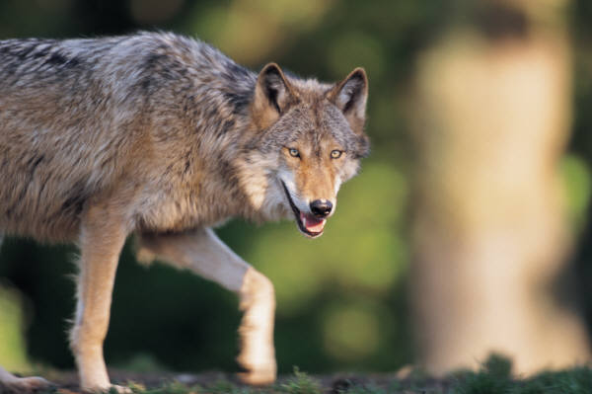


Background information on the Mexican Gray Wolf

Few animals are as misunderstood as the wolf. Few animals ignite such controversy. Yet, it is a story unfolding right here in our state, and its conservation connection has roots here at the ABQ BioPark Zoo.

Mexican gray wolves were once found in montane forests, grasslands, and shrub lands of central and northern Mexico, southwest Texas, southern New Mexico and southeastern Arizona. In the late 1800’s, as human populations in the southwest began to increase, a campaign was begun to eradicate wild Mexican gray wolves due to perceived threats to human safety, competition for game, and destruction of livestock. By 1970, the last known Mexican gray wolf in the U.S. was killed.

Shortly thereafter, the remaining wild wolves in Mexico were captured; meaning the entire wild population of wolves had been eradicated. The remaining wild wolves were combined with Mexican gray wolves already existing in captivity, and the captive breeding program began.

The ABQ BioPark Zoo has been involved with the Mexican gray wolf breeding program since the mid-1990s in collaboration with other zoos and sanctuaries that house Mexican gray wolves as part of AZA’s Species Survival Plan. The goal of the SSP is to develop a healthy, self-sustaining captive population with the highest possible amount of genetic and demographic diversity. The Species Survival Plan also creates a network for these facilities to share information regarding general husbandry techniques, veterinary care and research. At each facility, care is taken to make sure that captive wolves have limited contact with humans. Whenever possible, exhibits and holding areas are designed to replicate natural conditions.

Not all captive wolves will be released in the wild. Those wolves that remain in zoos are important ambassadors for their species. Many zoo visitors are compelled to protect and care for wolves after having the chance to see one up close. Zoos also provide an opportunity for people to learn more about wolves and wolf conservation.

The first wolves were released in March of 1998. There is currently an active reintroduction program in the United States in the Blue Range Wolf Recovery Area (BRWRA) of Arizona and New Mexico, and a proposed program in Mexico. The end of 2011 census of the reintroduced free-ranging population in the BRWRA recorded was estimated to total at least 58 wolves which included at least 18 pups surviving into 2012. The reintroduced population is establishing itself as a naturally functioning wolf population. There is natural reproduction and survival, and packs are forming on their own. The majority of the population in the reintroduction area was born there. Eleven of fourteen packs in the recovery area were observed denning in the spring of the 2012. Many pups have been observed.

Monthly status reports on the reintroduced population can be found by visiting the Arizona Game and Fish Department website at http://www.azgfd.gov/w_c/es/wolf_reintroduction.shtml or by visiting the U.S. Fish and Wildlife Service website at http://www.fws.gov/southwest/es/mexicanwolf.

What Part of the Foot Do You Use?

Every animal has feet that are adapted for different uses and benefits, whether it be for walking, running, jumping, climbing, attacking, or defending.
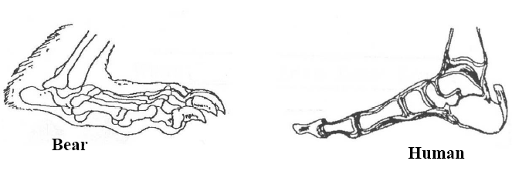

Bears and humans walk on the soles of their feet. This is called plantigrade. Members of the dog and cat families, however, walk on their toes or digits, called digitigrade. Wolves are members of the dog family (Canidae) and walk on their toes. Notice how far the heel is off the ground in the canid below compared to the animals above. This lengthens the stride and allows dogs and cats to run faster. Compare the front paw of the canid to the hand of the human. What major differences can you spot in the digits (fingers or toes)? The answer is on the next page along with some tracks made by members of the dog, cat, and bear families.
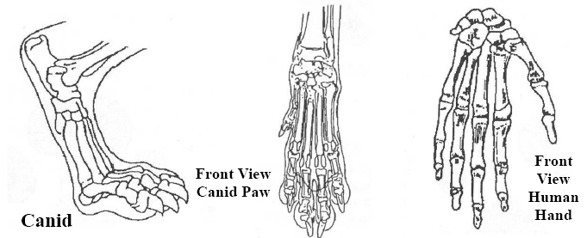

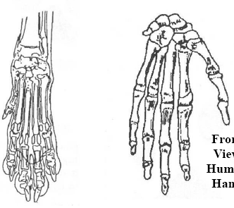
ANSWER: Humans have an opposable thumb on each hand. This allows humans to hold and manipulate objects. With the exception of a few species, most animals do not have this dexterity with their digits.
Thumb or digit

Whose Track is That?
Tracks not to scale.
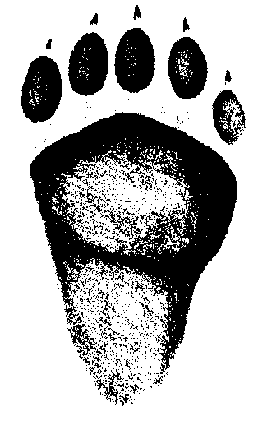
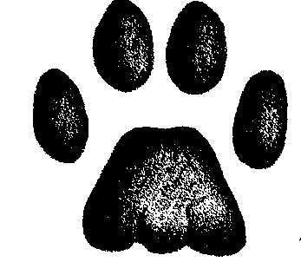
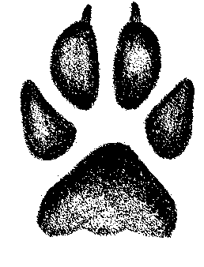
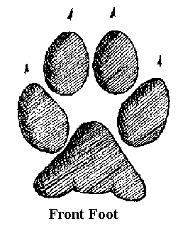
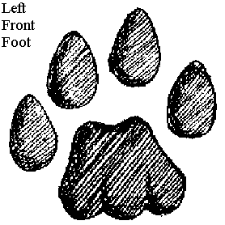
Black Bear
Mountain Lion
Coyote
Gray Wolf
Bobcat
What is the biggest difference between the tracks of members of the cat family and members of the dog family? What about the members of the bear family?
ANSWER: Most cats have claws that retract. Notice the cat tracks do not show claw marks. Bears have five toes, but cats and dogs only have four.
Wolf Awareness Activities
Grade K-1

1. How many wolves do you see?

2. What do you see the wolves doing? Circle the picture.
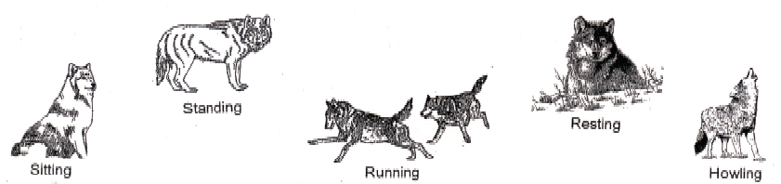

3. Where do Mexican gray wolves live? Circle the picture.
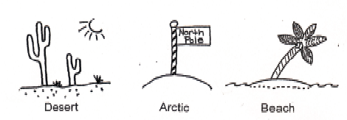
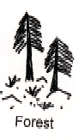

4. What do wolves eat? Circle the picture.

5. What does wolf fur feel like?

6. What do wolf teeth feel like?

ANSWER KEY:
1. Answers will vary. 2. Answers will vary. 3. Forest. 4. Deer.
Wolf Awareness Activities
Grade 2-5

Visit the Mexican Gray Wolf exhibit at the ABQ BioPark Zoo to find the answers to these questions.

Home of the Lobos
Draw a line -------- around the area where Mexican Wolves used to live.
Shade in the area where Mexican Wolves live now.
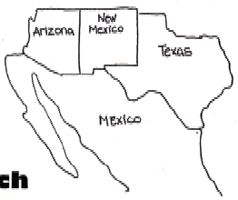

Adaptation Match
An adaptation is something that helps an animal to survive. For example, wolf ears are shaped for good hearing. Wolves can hear sounds from six miles away! Draw a line from each body part to the way it helps the wolf survive.

Long Tail Catching Food
Sharp Teeth Finding Food
Thick Fur Communication
Strong Claws Warmth
Nose Running and Digging

Fill in the blanks
1. The Spanish word for wolf is:
2. The Mexican gray wolf is an species.
3. Wolves eat , , rodents and small animals.

ANSWER KEY:
Adaptation match: Long tail-communication, sharp teeth-catching food, thick fur-warmth, strong claws-running and digging, nose-finding food
Fill in the blanks: 1. lobo, 2. endangered, 3. deer, elk,
Wolf Awareness Activities
Grade 6-12

Visit the Mexican Gray Wolf exhibit at the ABQ BioPark Zoo to find the answers to these questions.

Wolves in the Wild
Use < or > symbol to compare the number of wild Mexican gray wolves in New Mexico during each year.

1875 1600

1879 1892

1924 2005

Are You Wolf-Aware?
1. What makes up a wolf pack?

2. How do wolves communicate?

3. Why were wolves hunted in the late 1870s?

4. How is the Zoo involved with the reintroduction of the Mexican gray wolf?

ANSWER KEY:
Wolves in the Wild 1875 < 1600, 1879 > 1892, 1924 < 2005
Are You Wolf Aware? 1. Breeding pair, pups, yearlings. 2. Body postures, facial expressions, scent-marking, howling. 3. Considered to be a threat to human safety, competition for game animals, threat to livestock. 4. The Zoo has been breeding wolves since 1983, some of which have been released into the wild. The Zoo is now a holding facility with 3 male wolves on exhibit.
Wolf Awareness Activities
Grade 6-12

Wolf Observation
Choose one wolf to observe for 5 minutes. Every thirty seconds, record that wolf’s (and only that wolf’s) behavior. If the wolf goes to a place where you cannot see it, just record it as “out of view.” Don’t switch wolves midway through your observation period.

Wolf’s location in exhibit:
Date:
Time of first observation:
Time | Behavior Observed
Example 30 sec. | Running along the edge of the exhibit
Example 1 min. | Stopped running to sniff a log
30 sec.
1 min.
1 min. 30 sec.
2 min.
2 min. 30 sec.
3 min.
3 min. 30 sec.
4 min.
4 min. 30 sec.
5 min.
North American Predators
 | Habitat Type | Range | Food | Source of Water | Source of Shelter
Mexican Gray Wolf
Bobcat
Ocelot
Jaguar
Mountain Lion
An animal’s habitat provides the food, water, shelter and space it needs to survive. Observe these North American predators at the ABQ BioPark Zoo, and read the signs at the exhibit. Use that information and your observations to complete this chart. Do wolves compete with any of these animals for food or habitat type?
Answers – North American Predators
 | Habitat Type | Range | Food | Source of Water | Source of Shelter
Mexican Gray Wolf | Woodland, Forests | Northern Mexico and SE Arizona | Small game, deer, elk | Streams, creeks, any other water source in habitat | Burrows, under shrubs
Bobcat | Forests, mountains, semi-deserts, brushlands | Southern Canada to Baja California and Central Mexico | Rodents, rabbits, and birds. Occasionally deer. | Rivers | Trees and rock crevices
Arctic Fox | Open tundra, ice floes | N. Eurasia, Northern Canada and Alaska, Greenland, Iceland | Lemmings, sea birds, fish, seals, invertebrates, berries | Ice melt, streams, other watercourses | Burrows
Ocelot | Dense vegetation in forests, woodlands and scrublands | Extreme SW United States to Argentina | Rodents, rabbits, young deer, peccaries, birds, snakes, fish | Streams, small water courses | Trees
Jaguar | Scrubland, desert, savanna and forests. Always by water | Mexico to Brazil and Argentina. Rare in S. Arizona and New Mexico | Reccaries, deer, tapirs, capybara, caimen | Rivers, streams, lakes and marshes | Trees, under brush
Mountain Lion | Mountains, woodlands, and swamps | Western Canada and US to South America | Deer, elk, beavers, porcupines, hares, and wild hogs | Rivers, streams, lakes, swamps | Use caves, fallen trees, under shrubs, in trees
An animal’s habitat provides the food, water, shelter and space it needs to survive. Observe these North American predators at the ABQ BioPark Zoo, and read the signs at the exhibit. Use that information and your observations to complete this chart. Do wolves compete with any of these animals for food or habitat type?

